

Sort/Filter Tables

For One note meeting minutes

Andrei Alex | MS-Server | 04.04.2017

# Insert a table in OneNote 2016 for Windows

If you’d like to organize information in your notes, you can create a table.

1. Choose **Insert** > **Table**, and then use the grid to select the size of the table you want.
2. Click the lower-right highlighted cell.

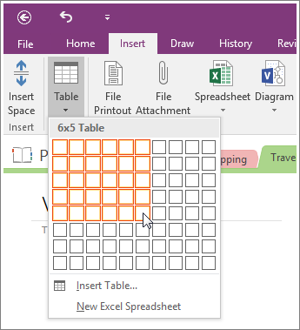

**NOTE:**  When you add a new table on a page, OneNote reveals the hidden **Table Tools** tab on the ribbon. Here, you can select and format the table. To return to these tools again at any time, click anywhere within a table on a notes page. You can also access most of the table commands by right-clicking any table cell and then clicking the **Table** command.

# Sort table data in OneNote 2016 for Windows

1. Click any cell in your table.
2. Click **Layout** > **Sort**, and then click either **Sort Ascending** or **Sort Descending**.

**NOTES:**

* To sort two or more rows in your table, and not the whole table at the same time, select the rows you want to sort, and click **Layout** > **Sort** > **Sort Selected Rows**.
* To set a particular row in your tables as the starting point for sorting, select the row, and click **Layout** > **Sort** > **Header Row**.

If you have Excel 2016 installed on the same computer as OneNote 2016, you can convert any table in your notes into an Excel spreadsheet. Click the table, and then click **Layout** > **Convert to Excel Spreadsheet**. When you double-click the **Edit** button in the embedded spreadsheet that appears, it will open in Excel.